Remote Learning –
A Guide for Parents & Carers

We use ClassDojo and Zoom to enable all of our pupils to access resources, communicate with their teachers and to learn from home during the pandemic. As much as possible, teaching will follow the original class plan for the term.

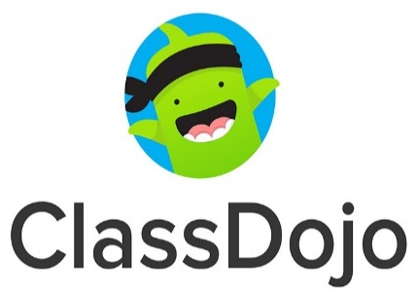

ClassDojo is a safe and secure solution for families to access learning materials directly from their class teachers, as well as a secure method of communicating with the school. Work may be set directly through ClassDojo or be physically posted/delivered home.

Zoom or Microsoft Teams will be used where appropriate to support children’s learning and social interaction and so that all members of the class are physically able to see each other. Please be aware that all participants in a zoom call will be able to see and hear each other. We recommend that you place the device you are using for video conversation so that no one else can be seen on screen and also that no address or location is visible. If you have any concerns about this please contact your class teacher via ClassDojo

If you require any help or support with your child's learning contact them via ClassDojo or email the school office.

In addition to work set through ClassDojo, our pupils have access to the following learning platforms:

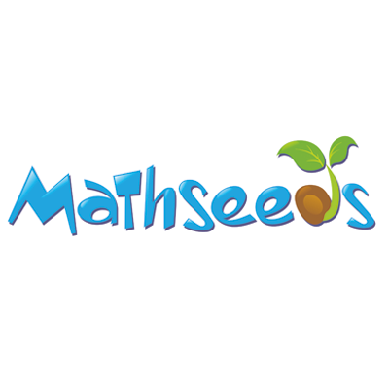 | 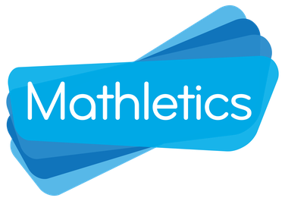 | 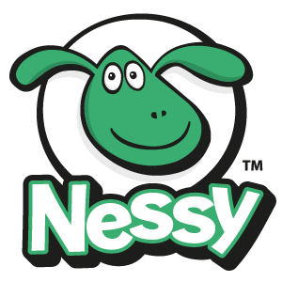

The images are linked to the appropriate website. Each pupil has a unique login to each of the above platforms. Mathseeds is available for Lower School pupils, Mathletics for children in Middle and Upper School. Please contact your teacher via ClassDojo if you do not have these details.

Useful Links
In addition to the platforms above, the following list has been created with websites to further support learning. All the websites are secure, trustworthy and age-appropriate.

Top Marks - English | Top Marks - Maths
ICT Games - Maths/English | Phonics Play
Virtual Tours- Museums and galleries | SEND Teaching Resources
CBeebies Games and Activities | Oxford Owl Reading Activities
Jump Start Jonny - PE for all age groups | Transum Maths Activities

We want to support your child to continue learning at the right level with sequential learning activities. New learning and over-learning remain equally important in helping children understand and contextualise skills and knowledge.
Please don’t hesitate to be in touch with school if you would like any further explanation or support.

